Project Design Phase-II
Data Flow Diagram & User Stories

Date | 03 October 2026
Team ID | SWTID-2026-6867
Project Name | Streamlining IT Procurement: Automating Standard Laptop Orders with Flow Designer
Maximum Marks | 4 Marks

Data Flow Diagrams:
A Data Flow Diagram (DFD) is a traditional visual representation of the information flows within a system. A neat and clear DFD can depict the right amount of the system requirement graphically. It shows how data enters and leaves the system, what changes the information, and where data is stored.
Flow:

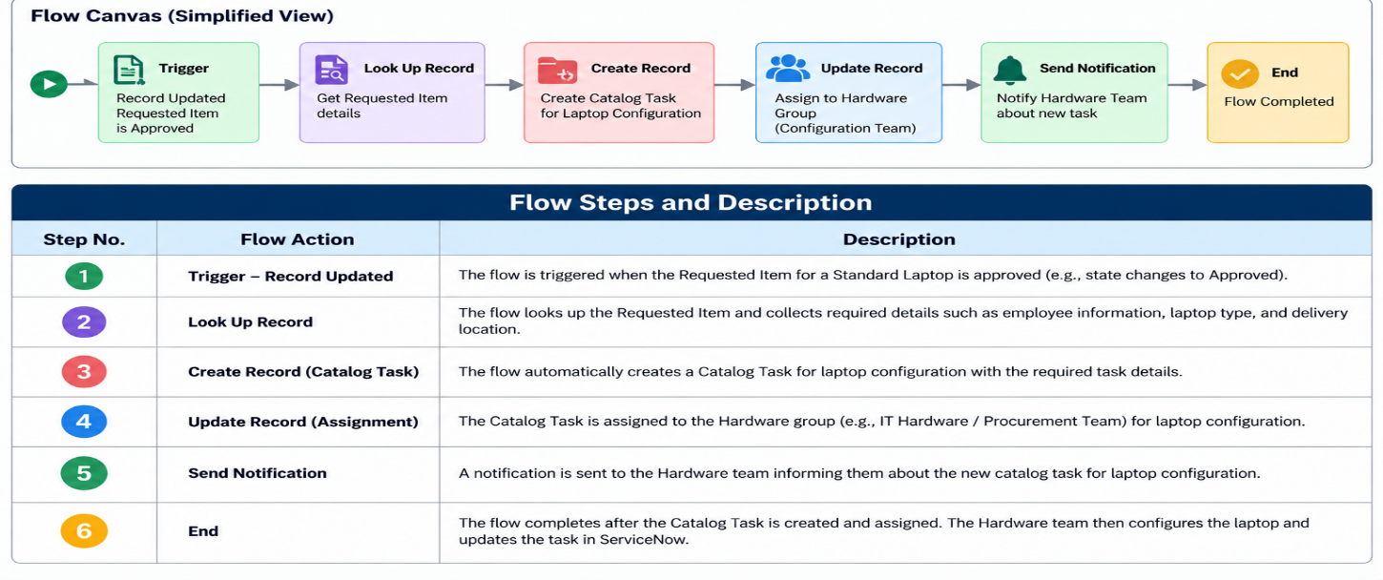
Example: DFD Level 0 – Standard Laptop Procurement Automation
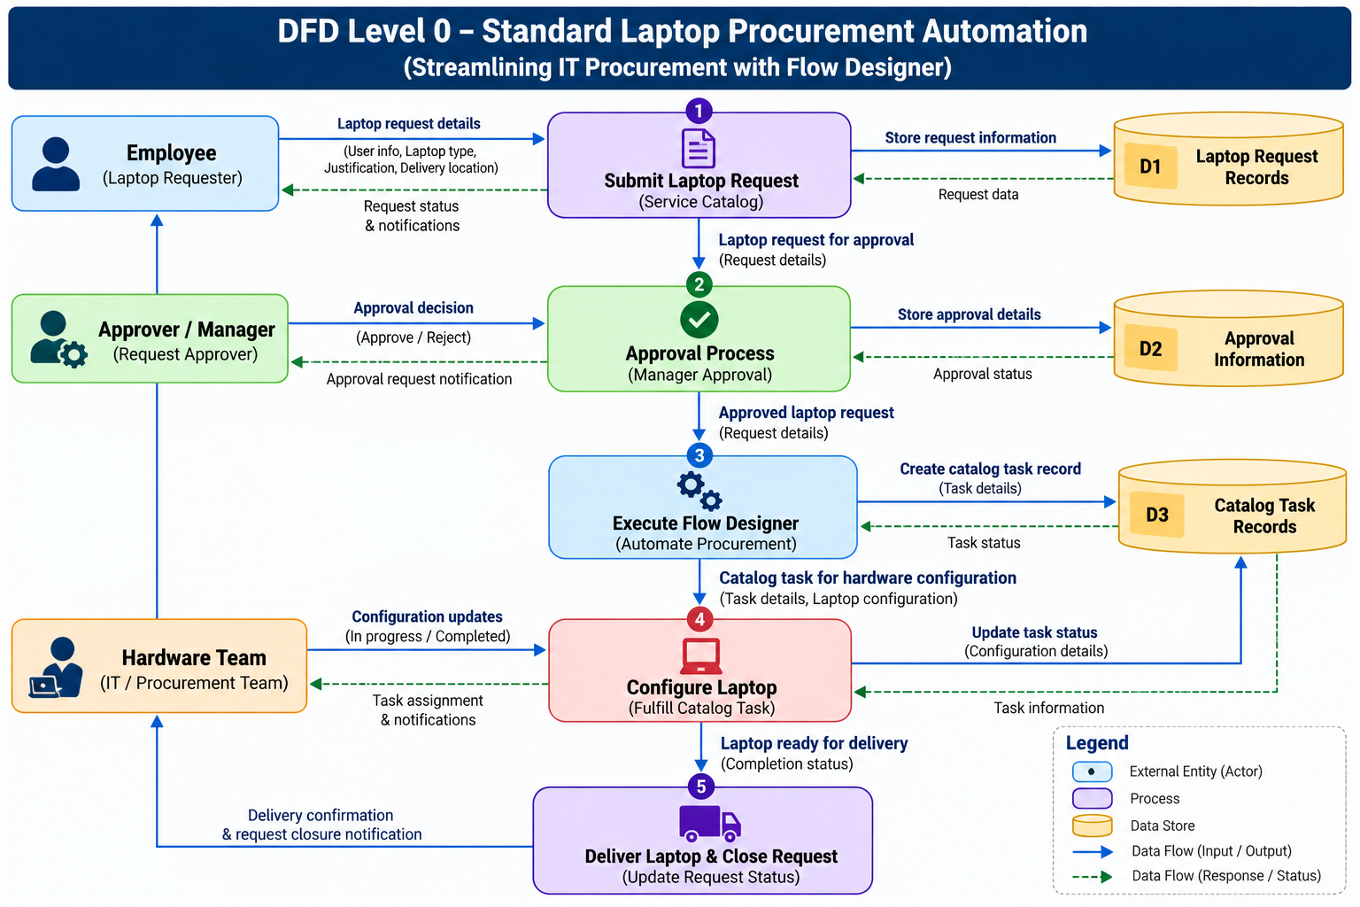
User Stories
Use the below template to list all the user stories for the product.
User Type | Functional Requirement (Epic) | User Story Number | User Story / Task | Acceptance criteria | Priority | Release
Employee | Standard Laptop Request | USN-1 | As an employee, I can request a standard laptop through the Service Catalog by providing the required request details. | The standard laptop request is submitted successfully with all required information. | High | Sprint-1
Employee | Standard Laptop Request | USN-2 | As an employee, I can view the status of my standard laptop request after submission. | The employee can view the current request status in ServiceNow. | Medium | Sprint-1
Approver / Manager | Laptop Request Approval | USN-3 | As an approver, I can review and approve or reject a standard laptop request. | The request status is updated according to the approval decision. | High | Sprint-1
System / Flow Designer | Procurement Automation | USN-4 | As the system, I can trigger the Flow Designer process when the standard laptop request is approved. | The Flow Designer flow starts automatically after the request is approved. | High | Sprint-1
System / Flow Designer | Catalog Task Creation | USN-5 | As the system, I can automatically create a Catalog Task for the approved standard laptop request. | A Catalog Task is created automatically with the required laptop configuration information. | High | Sprint-1
Hardware Team | Hardware Configuration | USN-6 | As a Hardware team member, I can receive an automatically assigned configuration task for an approved laptop request. | The Catalog Task is assigned to the Hardware group and contains the required configuration details. | High | Sprint-1
Hardware Team | Laptop Configuration | USN-7 | As a Hardware team member, I can configure the standard laptop and update the task when configuration is completed. | The laptop is configured and the Catalog Task is updated to the appropriate completed status. | High | Sprint-1
Employee | Laptop Delivery | USN-8 | As an employee, I can receive the configured laptop after the hardware configuration task is completed. | The employee receives the configured standard laptop and the request can be completed. | Medium | Sprint-2

